PACS 82.45.Aa, 81.05.Uw, 82.47.Uv ISSN 1729-4428

I.P. Yaremiy¹, M.L. Mokhnatskyi¹, P.I. Kolkovskyi¹, L.V. Mokhnatska¹, S.I. Yaremiy², A.I. Kachmar¹

Promising Cathode Material for Supercapacitors LaFe_{0.5}Cr_{0.5}O₃ Perovskite Nanoparticles

Vasyl Stefanyk Precarpathian National University, 57 Shevchenko Str., 76025 Ivano-Frankivsk, Ukraine
Ivano-Frankivsk National Medical University, 2 Galitska Str., Ivano-Frankivsk, Ukraine

In this work, the Perovskite powders LaFe_{0.5}Cr_{0.5}O₃ with space group of P m -3 m was obtained by sol-gel method. The specific surface area of synthesized material is 14 m²/g. Moreover, the nanoscale powders of LaFe_{0.5}Cr_{0.5}O₃ have been tested as a cathode material for electrochemical supercapacitors. The CVA and charge-discharge curves were obtained at 0.5 mV/s to 16 mV/s and 0.5 mA/s to 16 mA/s scan rates accordingly. Thus, the cathode material LaFe_{0.5}Cr_{0.5}O₃ demonstrates the specific capacity up to 16 F/g at discharge scan rate 0.5mV/s. Additionally, the maximum of the specific capacity was calculated and it is determined that C is 29.26 F/g, and specific capacity of double electric layer C_{DEL} is 3.44 F/g. It was determined that, the contribution of the redox reactions in specific capacity is 88%. Consequently, the Nyquist plots and Mott-Schottky plots for LaFe_{0.5}Cr_{0.5}O₃ were obtained, which consist of two parts with different conductivity type, received the values of ﬂat band potential E_{fb} is -1V for n type and E_{fb} is 0.16V for p type of conductivity.
Keywords: sol-gel method, perovskite structure, supercapacitor, impedance, spectroscopy, specific capacity

Introduction

Due to the rapid development of electronics the number of personal gadgets is increasing such as mobile phones, smart watches, fitness bracelets, wireless headphones, mini cameras, smart glasses, etc. Moreover, every year they become more complex and more functional, which leads to higher energy consumption. Consequently, against this background there is a need for development new energy storage devices with better capacity, less weight, cheaper, more reliable and environment friendly [1].
Thus, supercapacitor is one of the alternative types of energy storage. The advantages of supercapacitor’s compare to classic batteries are low toxicity, high efficiency (more than 95%), less weight, etc. All this makes supercapacitors very promising in the future. Therefore, research new materials for supercapacitors with predefined properties is relevant today [2].
The perovskite is a complex oxide with the general formula АВО₃. It can be realized in a big number of oxide systems, and crystals of perovskites distributed on Earth. Moreover, ABO₃attract enormous interest of researchers due to their unique electrical and magnetic properties [2]. Additionally, the complex oxides with perovskite structure have been widely used in various fields, such as cathodes in solid oxide fuel cells, active oxidation catalysts, environmental monitoring films, active materials for chemical sensors for the detection of humidity, alcohols and gases, and so forth [3,4,5].
In this work, the nano-sized LaFe_{0.5}Cr_{0.5}O₃ with perovskite structure has been synthesized. The structure and size of the obtained material were determined. Moreover, obtained material was applied as a cathode material for an electrochemical supercapacitor. The specific capacity was determined at different scan rate. The value of maximum of specific capacity was calculated. The conductivity type of tested material at different applied potentials was determined.

Experiment technique

The nano-sized powder of perovskite structure LaFe_{0.5}Cr_{0.5}O₃ was obtained by sol-gel method. Thus, for the synthesis was used the nitrates crystal hydrates of corresponding metals and citric acid dissolved in distilled water. The level of PH=7 was controlled by adding 25 % ammonia solution. After that, the obtained solution was dried with access to air until it became solid. Dried xerogel heated to a temperature of 230°C to activate auto-burning [6, 7].
Phase composition analysis and determination of crystal structure of obtained materials was performed by DRON-3 diffractometer with Cu (Kα) radiation and X-rays focusing on the Bragg-Brentano. The experimental diffractograms were analyzed with software “FullProf”.
The specific surface of the samples was measured by chromatographic method in gas sorption analyzer NOVA Quantachrome 2200е. The method consists in determination of the volume of adsorbed (desorbed) nitrogen by the samples at a temperature of liquid nitrogen and further calculation of the specific surface by BET method.
The electrochemical investigation of obtained material were measured using a three-electrode system with 6 M KOH electrolyte. The working electrode was prepared as a composition of active material and acetylene soot in a proportion of 9 to 1 wrapped in nickel mesh, for counter electrode was used platinum wire, and reference electrode (Ag/AgCl).
Galvanostatic charge-discharge curves, cyclic voltammetry performances, and electrical impudence spectroscopy in the frequency range 10⁵-10⁻² Hz were carried on Autolab PGSTAT/FRA2 workstation with GPES and FRA-2 software [8].

Results and Discussion

The powders of complex oxide LaFe_{0.5}Cr_{0.5}O₃ with perovskite structure were obtained by sol-gel method with auto-burning. The detailed synthesis of this material described in the previous article [9]. The figure 1 shows the diffraction patterns of dried xerogel (Ammonium nitrate) (a), and synthesized nano-sized powder of the perovskite structure LaFe_{0.5}Cr_{0.5}O₃ (b). Also, fig 1 contains theoretical approximation by Rietveld method of experimental diffraction patterns, calculated in software “FullProf”.
The synthesized material has space group P m -3 m with lattice size а = 3,904 Å and cell volume V = 59,5 Å³, calculated density ρ = 6,724 g/cm³. Figure 2 shows the transmission electron microscope images in scale 50 nm (a), and 10 nm (b). The average size of the particles is about 40-60 nm.

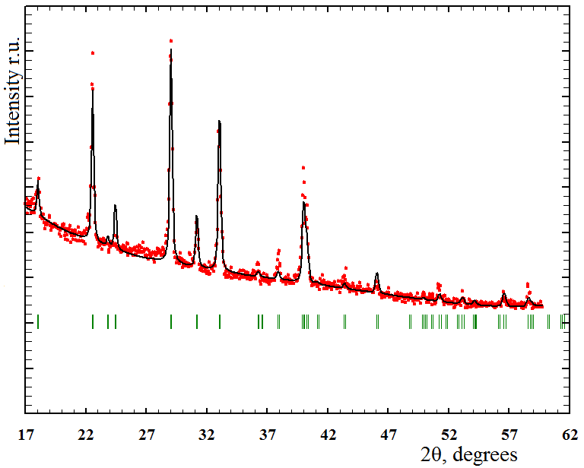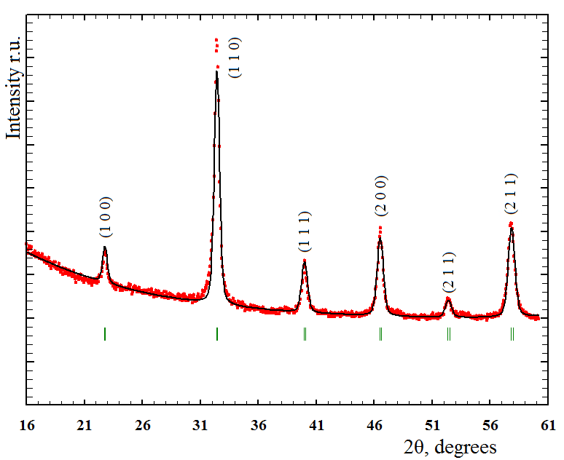
a b

Fig 1. Diffractogram of dried xerogel (a), and synthesized nano-sized powder of perovskite structure LaFe_{0.5}Cr_{0.5}O₃ (b).

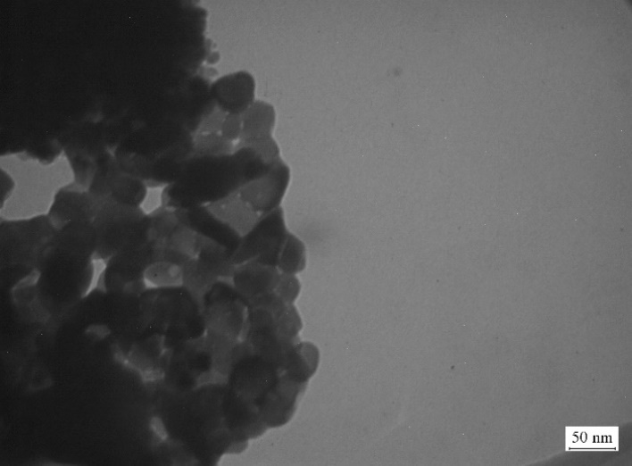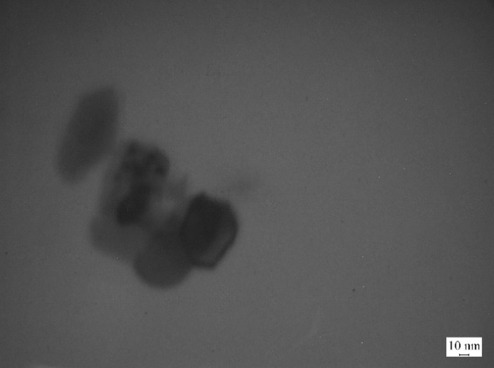

a b

Fig 2. TEM pictures of synthesized nano-sized powder of complex oxide perovskite structure LaFe_{0.5}Cr_{0.5}O₃ in scale 50 nm (a), and 10 nm (b).

The typical asymmetric CVA curves of LaFe_{0.5}Cr_{0.5}O₃ electrode in 6 M KOH electrolyte in an enlarged potential range of 0.0 to 0.5 V under scan rate range of 0.5 to 16 mV/s, are showed in fig.3. The CVA curves of obtained LaFe_{0.5}Cr_{0.5}O₃ electrode are demonstrating the deviation from default electrochemical double layer behavior and redox peaks at ≈ 0.28V confirms the pseudocapacitive characteristics. There is a visible rise in peak current densities with linear increase of scan rates, which demonstrates the sufficient rate of ionic and electronic transportation during the redox reaction in electrolyte with good proficiency rate. Thus, in between scan rate from 0.5 to 16 mV/s, there is no redox peak-shift was observed, and it once again shows the excellent stability and low internal resistance [1, 10]. The peaks near 0.35V on the oxidation branch corresponds to the oxidation of Fe²⁺ to Fe³⁺ due to the intercalation of oxygen ions in an oxygen vacancy [1].

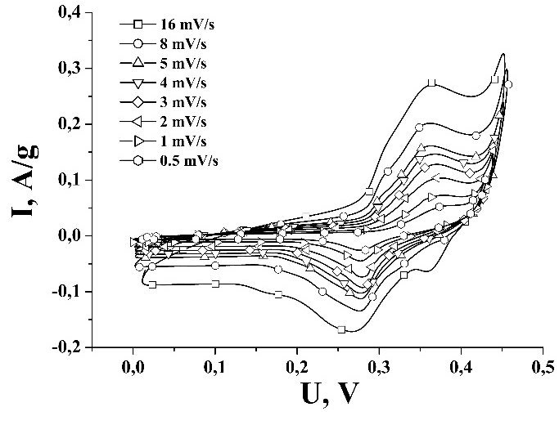
Fig 3. CVA of the LaFe_{0.5}Cr_{0.5}O₃/KOH system for scan rates from 0.5 to 16 mV/s.

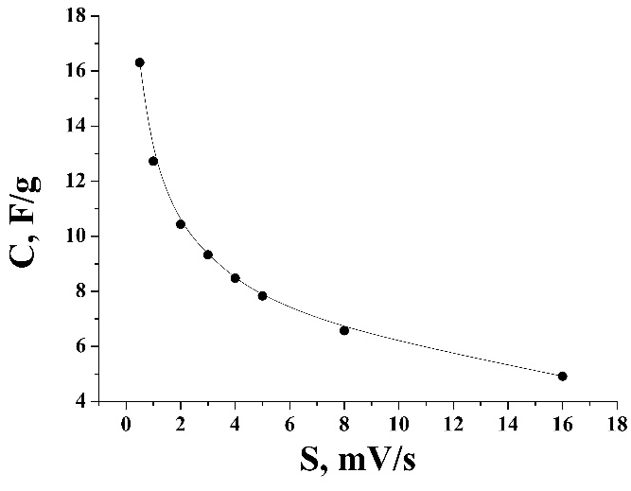
Fig 4. Specific capacity of the LaFe_{0.5}Cr_{0.5}O₃/KOH system for scan rates from 0.5 to 16 mV/s.

The figure 4 shows the dependence of the specific capacity on the scan rate of the research material LaFe_{0.5}Cr_{0.5}O₃. We can see the non-linear decrease of specific capacity with increasing scan rate. The maximum of the specific capacity is 16.3 F/g at scan rate of 0.5 mV/s. The specific capacity (C) consists of two parts, the first part is the capacity of the double electric layer (C_{DEL}) and the second is capacity of the redox reactions (C_{F}) [10]. From CVA curves view on the fig 3.a we can make an assumption that the main part of LaFe_{0.5}Cr_{0.5}O₃ capacity contributes from the redox reactions.

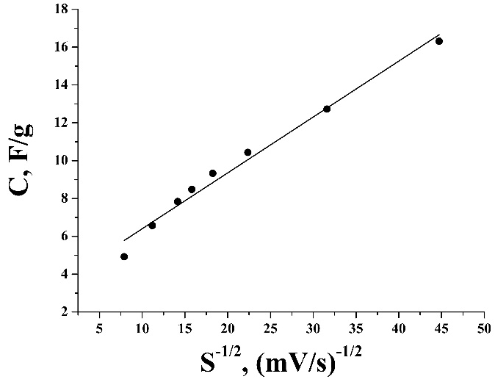
Fig 5. Dependence of specific capacity on s^{-1/2} for LaFe_{0.5}Cr_{0.5}O₃.
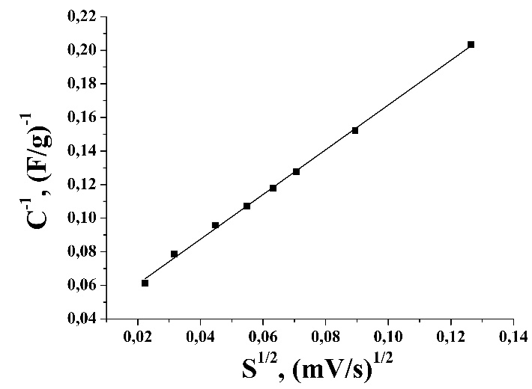
Fig 6. Dependence of C⁻¹ on s^{1/2} for LaFe_{0.5}Cr_{0.5}O₃.

From the kinetic model [11], diffuse component (C_{F}) depends on scan rate due to it is a function of the reaction time, and scan rate is inverse to the time of diffusion. In case of linear diffusion, we can use the equation: $C=C_{s=∞}+a\sqrt{s}$, where $C_{DEL}=C_{s=∞}$ and $a$ is a constant value. Figure 5 shows the linearly dependency of specific capacity (C) on s^{-1/2}, we can determine the C_{DEL} by the extrapolation of this line to the Y axis. Nevertheless, the capacity of the double electric layer C_{DEL} is 3.44 F/g. Additionally, we can extrapolate the dependency of the specific capacitance on the scan rate to the other side s is 0. 1/C decrease linearly with s^{1/2}, so we can use such equation $\frac{1}{C}=\frac{1}{C_{x=0}}=b\sqrt{s}$, where b is a constant value [10]. The figure 6 shows the dependency of C⁻¹ on s^{1/2} for obtained LaFe_{0.5}Cr_{0.5}O₃, extrapolation of this dependency to the Y axis made it possible to get the maximum of the specific capacity C is 29.26 F/g. The contribution of the redox reactions in specific capacity is 88%, which confirms our assumption. Figure 7 shows the charge-discharge curves of the electrochemical system based on LaFe_{0.5}Cr_{0.5}O₃ electrode. There are linear sections on discharge curves with different tilt angles, they indicate different mechanisms of electric energy storage. To calculate the amount of specific capacitance (C_{m}) we can use the formula: $C_{m}=\frac{C}{m}=\frac{I∆t}{∆Um}$, where I (mA) is the discharge current, Δt (s) is the discharge time, ΔU (V) is the potential during the discharge, and m (g) is the mass of the active material inside the electrode[10].

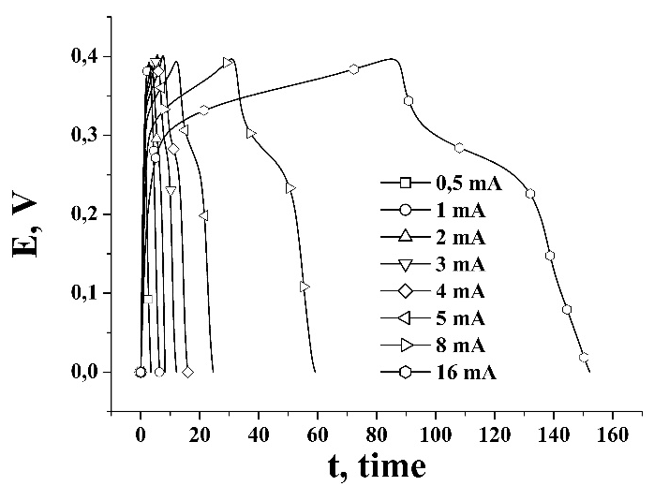

Fig 7. The charge-discharge curves of LaFe_{0.5}Cr_{0.5}O₃ in the potential window from 0 to 0.4 V at various currents. 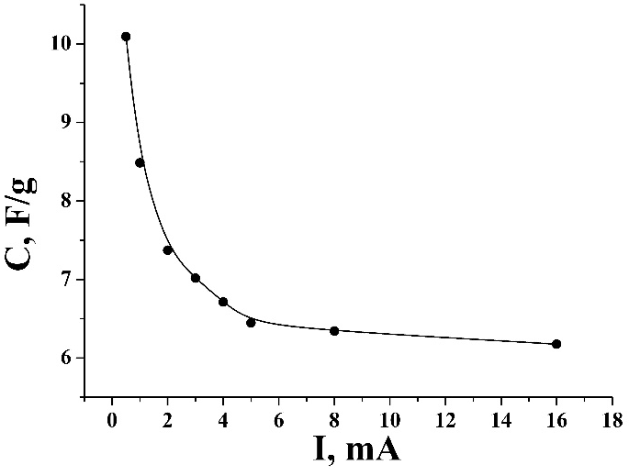
Fig 8. The specific capacitance density of LaFe_{0.5}Cr_{0.5}O₃, measured from discharge part of the charge discharge curves.

The specific capacitance (Cm) values are presented at the fig 8. We can see that the capacity decreases when discharge current increases. It can be explained by the fact that there is not enough time for ions to completely infiltrate into the electrode and enter vacancies. The maximum of specific capacity 10.1 F/g is obtained at the discharge current of 0.5 mA.
Thus, the electron impedance spectroscopy in the frequency range 10⁵-10⁻² Hz measurements were made to determine the electrical properties of the nano-sized complex oxide perovskite structure LaFe_{0.5}Cr_{0.5}O₃. The Nyquist plots at different values of potential are shown in fig 9.

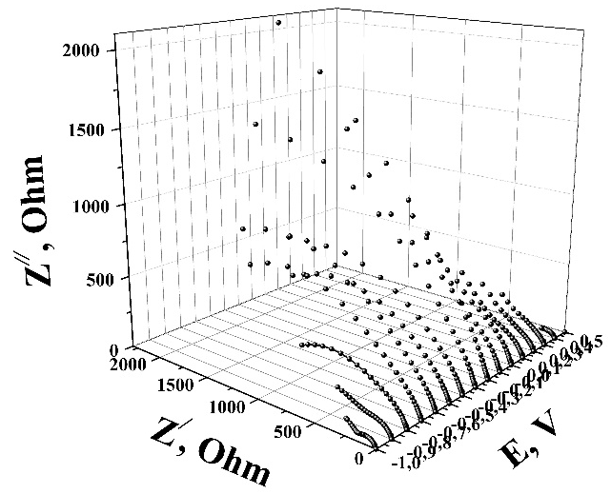
Fig 9. Nyquist plots of LaFe_{0.5}Cr_{0.5}O₃

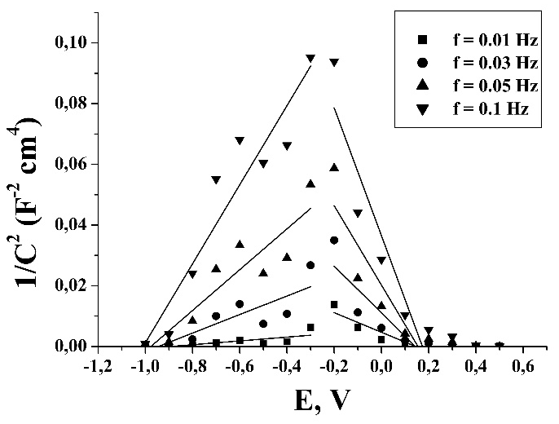
Fig 10. Mott-Schottky plots of LaFe_{0.5}Cr_{0.5}O₃

The Nyquist plot at the electrode potential -1V consists of small semicircle on high frequencies structure and straight line on low frequencies. Semicircle is the result of energy consumption for ion transportation through perovskite structure and straight line corresponds to double electric layer capacity. The electrode potential changing from -1V to -0.3V leads to semicircle straightening and resistance increase. During further potential increasing from -0.3V to 0.5V resistance decrease and plots return to original view with two parts.
Therefore, the Poisson equation can be modified with Boltzmann distribution for electrons distribution in the region of space charge and Gauss's law for electric field on the border of charge to obtain Mott-Schottky equation [12]:
$$\frac{1}{С^{2}}=\frac{2}{εε_{0}A^{2}eN_{D}}\left(V-V_{fb}-\frac{k_{B}T}{e}\right),$$
where ε and ε₀ are dielectric constant and vacuum permittivity, e is an electron charge, A is BET surface area, N_{D} is a carrier concentration, E and E_{fb} are electrode potential and ﬂat band potential values, T – an absolute temperature, k_{B} – Boltzmann constant. The linear fitting of the low-potential part allows calculating the ﬂat band potential (E_{fb}), and the slope of the curve corresponds for the type of conductivity. The Mott-Schottky plots are presented in fig 10, they can be divided into two parts with different type of conductivity: from -1V to -0.3V and -0.2V to 0.5V with the same point of division as Nyquist plots. First area corresponds for n type of conductivity with E_{fb} is -1V, and p type for the second area with E_{fb} is 0.16V.

Conclusions

The nano-sized powder of perovskite structure LaFe_{0.5}Cr_{0.5}O₃ was successfully obtained by sol-gel method, which confirms by X-rays analysis and transmission electron microscope images.
Moreover, the LaFe_{0.5}Cr_{0.5}O₃ was used as cathode material and demonstrates the specific capacity up to 16 F/g at discharge scan rate 0.5mV/s.
It was determined that, the calculated maximum of the specific capacity C is 29.26 F/g, where 88% is specific capacity of redox reactions.
LaFe_{0.5}Cr_{0.5}O₃ shows different types of conductivity depends on applied potential, received the values of ﬂat band potential E_{fb} is -1V and E_{fb} is 0.16V for n type and p type of conductivity accordingly.

Yaremiy I.P. - Doctor of Sciences, Professor, of the Department of Material Science and New Technology;
Mokhnatskyi M.L. – PhD student, of the Department of Material Science and New Technology;
Kolkovskyi P.I. – Doctoral student of the Department of Material Science and New Technology;
Mokhnatska L.V. – PhD student, of the Department of Material Science and New Technology;
Yaremiy S.I. – PhD, teacher of the Department of Medical Informatics, Medical and Biological Physics;
Kachmar A.I. – PhD of the Department of Material Science and New Technology;

Reference

Reference

[1]. Hussain, S., Javed, M.S., Ullah, N., Shaheen, A., Aslam, N., Ashraf, I., Abbas, Y., Wang, M., Liu, G. and Qiao, G., 2019. Unique hierarchical mesoporous LaCrO3 perovskite oxides for highly efficient electrochemical energy storage applications. Ceramics International, 45(12), pp.15164-15170.
[2]. Polat, O., Durmus, Z., Coskun, F.M., Coskun, M. and Turut, A., 2018. Engineering the band gap of LaCrO 3 doping with transition metals (Co, Pd, and Ir). Journal of Materials Science, 53(5), pp.3544-3556.
[3]. Hui, S., Jiayue, X. and Anhua, W., 2010. Preparation and characterization of perovskite REFeO3 nanocrystalline powders. Journal of Rare earths, 28(3), pp.416-419.
[4]. Khetre, S.M., Jadhav, H.V. and Bamane, S.R., 2010. Synthesis and characterization of nanocrystalline LaFeO3 by combustion route. Rasayan Journal Chemistry, 3(1), pp.82-86.
[5]. Deganello, F., Marcì, G. and Deganello, G., 2009. Citrate–nitrate auto-combustion synthesis of perovskite-type nanopowders: a systematic approach. Journal of the European Ceramic Society, 29(3), pp.439-450.
[6]. Kopaev, A., Bushkova, V. and Ostafiychuk, B., 2013. Sol-Gel Synthese und Eigenschaften der weichmagnetischen Nanoferrite und Verbundwerkstoffen. Physik und Technologie der Nanoferrite mit dem Bariumtitanat (Lap Lambert Academic Publishing, Saarbrücken, 2013).
[7]. Остафійчук, Б.К., Мохнацький, М.Л., Яремій, І.П., Мохнацька, Л.В., Бушкова, В.C. and Луцась, А.В., 2015. Синтез структура та електрохімічні властивості нанорозмірного порошку LaCrO3. Науковий вісник Чернівецького університету, 4(1), pp. 34-38.
[8]. Гасюк, И.М., Угорчук, В.В., Стрелецкий, Ю.И., Бачук, В.В. and Матейшина, Ю., 2007. Автоматизированная многока нальная установка циклирования электрохимических ячеек. Датчики и системы, (6), pp.39-38.
[9]. Yaremiy, I.P., Mokhnatskyi, M.L., Mokhnatska, L.V., Yaremiy, S.I. and Kachmar, A.I., 2017. Promising Cathode Material for Lithium Power Sources LaFe0. 5Cr0. 5O3. Physics and Chemistry of Solid State, 18(4), pp.444-448.
[10]. Ostafiychuk, B.K., Kolkovska, H.M., Yaremiy, I.P., Rachiy, B.I., Kolkovskyi, P.I., Ivanichok, N.Y. and Yaremiy, S.I., 2020. Synthesis and electrochemical properties of LaMnO3 orthosized nanomaterial for supercapacitor applications. Physics and Chemistry of Solid State, 21(2), pp.219-226.
[11]. Xu, M., Kong, L., Zhou, W. and Li, H., 2007. Hydrothermal synthesis and pseudocapacitance properties of α-MnO2 hollow spheres and hollow urchins. The Journal of Physical Chemistry C, 111(51), pp.19141-19147.
[12]. Kachmar, A.I., Boichuk, V.M., Budzulyak, I.M., Kotsyubynsky, V.O., Rachiy, B.I. and Lisovskiy, R.P., 2019. Effect of synthesis conditions on the morphological and electrochemical properties of nitrogen-doped porous carbon materials. Fullerenes, Nanotubes and Carbon Nanostructures, 27(9), pp.669-676.

І.П. Яремій¹, М.Л. Мохнацький¹, П.І. Колковський¹, Л.В. Мохнацька¹, С.І. Яремій², А.І. Качмар¹

Перспективний катодний матеріал для супер конденсаторів нанорозмірний перовскитний матеріал LaFe_{0.5}Cr_{0.5}O₃

ДВНЗ «Прикарпатський національний університет імені Василя Стефаника», вул. Шевченка, 57, Івано-Франківськ, 76025
Івано-Франківський національний медичний університет, вул. Галицька, 2, Івано-Франківськ

У цій роботі, порошки перовскиту LaFe_{0.5}Cr_{0.5}O₃ з просторовою групою P m -3 m були отримані золь-гель методом. Площа питомої поверхні синтезованого матеріалу 14 м²/г. Також, нанорозмірні порошки LaFe_{0.5}Cr_{0.5}O₃ були випробувані як катодний матеріал для електрохімічних супер конденсаторів. Отримано CVA криві при швидкостях сканування від 0,5 мВ/с до 16 мВ/с та заряд розрядні криві при швидкостях сканування від 0,5 мA/с до 16 мA/с. Катодний матеріал LaFe_{0.5}Cr_{0.5}O₃ демонструє питому ємність 16 Ф/г при швидкості розряду 0,5 мА/с. розрахований максимум питомої ємності C становить 29.26 Ф/г, там питома ємність подвійного електричного шару C_{DEL} становить 3.44 Ф/г. Було визначено, що вклад окисно-відновних реакцій у питому ємність складає 88%. Отримано діаграми Найквіста та Мотта-Шотки для LaFe_{0.5}Cr_{0.5}O₃, котрі складаються х двох частин з різним типом провідності, отримані значення потенціалів плоскої зони E_{fb} становить -1В для n типу та E_{fb} становить 0.16V для p типу провідності.
Ключові слова: золь-гель метод, структура перовскиту, супер конденсатор, імпеданс, спектроскопія, питома ємність.

